**SPSS Homework Data Exploration WEEK 3**

Homework

**Disclaimer: Homework is made up for educational purposes.**

**Answer the following questions.**

**SPSS Statistics:**

1. HR of company argues that their staff is young. She claims average age of all employees is equal to 31 years old. You have given sample data. Test if hypothesis is true or not for population.

|  |  |  |  |  |
| --- | --- | --- | --- | --- |
| **One-Sample Statistics** | | | | |
|  | N | Mean | Std. Deviation | Std. Error Mean |
| Age | 1470 | 36.9238 | 9.13537 | .23827 |

|  |  |  |  |  |  |  |
| --- | --- | --- | --- | --- | --- | --- |
| **One-Sample Test** | | | | | | |
|  | Test Value = 31 | | | | | |
| t | Df | Sig. (2-tailed) | Mean Difference | 95% Confidence Interval of the Difference | |
| Lower | Upper |
| Age | 24.862 | 1469 | .000 | 5.92381 | 5.4564 | 6.3912 |

Sig. is 0. (p<0.05) It means age of sample is significantly different than 31. This hypothesis is not true.

The Mean Difference is 5.92381. The mean of sample is more the population mean.

2. Using the data set dietstudy.sav, determine whether there is a significant difference between the initial weight and the average final weight of the patients (variables wgt0 and wgt4, respectively)

|  |  |  |  |  |  |
| --- | --- | --- | --- | --- | --- |
| **Paired Samples Statistics** | | | | | |
|  | | Mean | N | Std. Deviation | Std. Error Mean |
| Pair 1 | Weight | 198.38 | 16 | 33.472 | 8.368 |
| Final weight | 190.31 | 16 | 33.508 | 8.377 |

|  |  |  |  |  |
| --- | --- | --- | --- | --- |
| **Paired Samples Correlations** | | | | |
|  | | N | Correlation | Sig. |
| Pair 1 | Weight & Final weight | 16 | .996 | .000 |

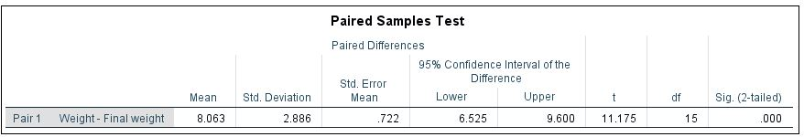

Sig. is 0. (p<0) There is a significant difference between initial weight and final weight. On average, Final weight is 8.063 less then initial weight.

3. Using the information in the database testmarket.sav, determine whether there is a significant difference in average sales volume (variable sales) for different market sizes (variable mktsize).

|  |  |  |  |  |  |
| --- | --- | --- | --- | --- | --- |
| **ANOVA** | | | | | |
| Units sold in thousands | | | | | |
|  | Sum of Squares | df | Mean Square | F | Sig. |
| Between Groups | 6618.844 | 2 | 3309.422 | 35.542 | .000 |
| Within Groups | 49257.438 | 529 | 93.114 |  |  |
| Total | 55876.283 | 531 |  |  |  |

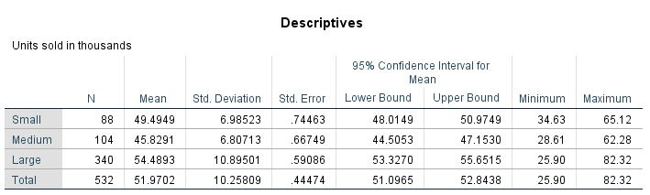

Sig. is 0. (p<0.05) There is significant difference between means for different market sizes in average sales volume.

4. Using the data set property_assess.sav, study the relationship between sale value of a house (variable saleval) and township (variable town).

|  |  |  |  |  |  |
| --- | --- | --- | --- | --- | --- |
| **ANOVA** | | | | | |
| Sale value of house | | | | | |
|  | Sum of Squares | df | Mean Square | F | Sig. |
| Between Groups | 1854754.675 | 4 | 463688.669 | 379.160 | .000 |
| Within Groups | 1216823.101 | 995 | 1222.938 |  |  |
| Total | 3071577.776 | 999 |  |  |  |

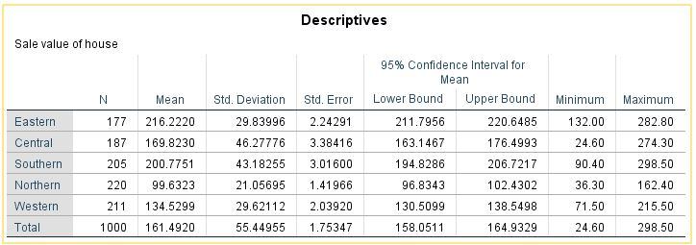

Sig. is 0. (p<0.05) There is significant difference between means for different town in average sales value.

**SPSS Modeler:**

5. Open “retail_purchase_data.text” from demos. Conduct visual retail basket analysis using web node.

6. Open “Worldsales.sav”. Build a pie chart and bar chart for of total revenue by countries. 7. Build histogram graph for income variable using histogram node in “Customer_dbase.sav “. 8. Build boxplot graph for age and education variables using boxplot in “Bankloan.sav”.

9. Find relationship between variables using scatterplot in meaningful manner in “customer_dbase.sav”.



QSS Analytics/Tədqiqat və İnkişaf Mərkəzi. Bütün hüquqlar qorunur. © www.dsa.az